Onology Creation

1. Create RDF or OWL from CoreNLP triples.
2. Outside ontology for portal current events: <http://dbpedia.org/page/News>
3. Connect our ontology to outside ontology.
4. Tools for Linking data to dbpedia: Google Open Refine, Top Braid

Top Braid Tool

1. 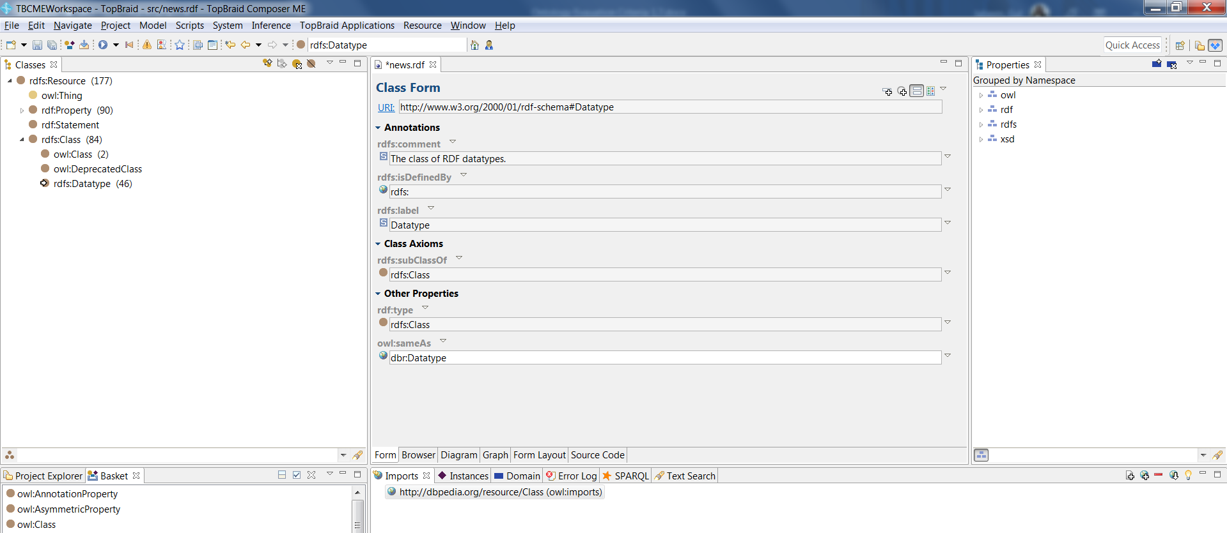First import RDF file in the Workspace.
2. Click on the resource and then click on link to dbpedia

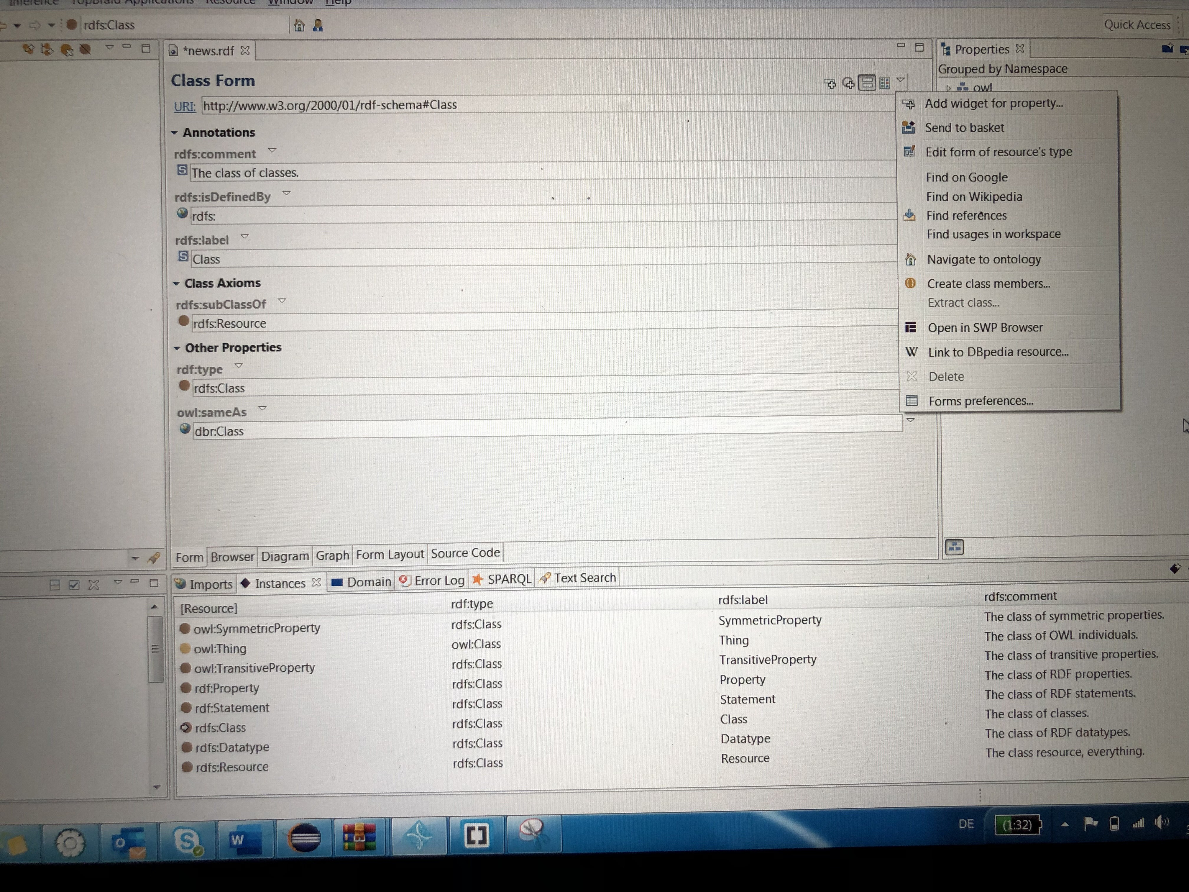

1. Click on the arrow and get a link of outside ontology

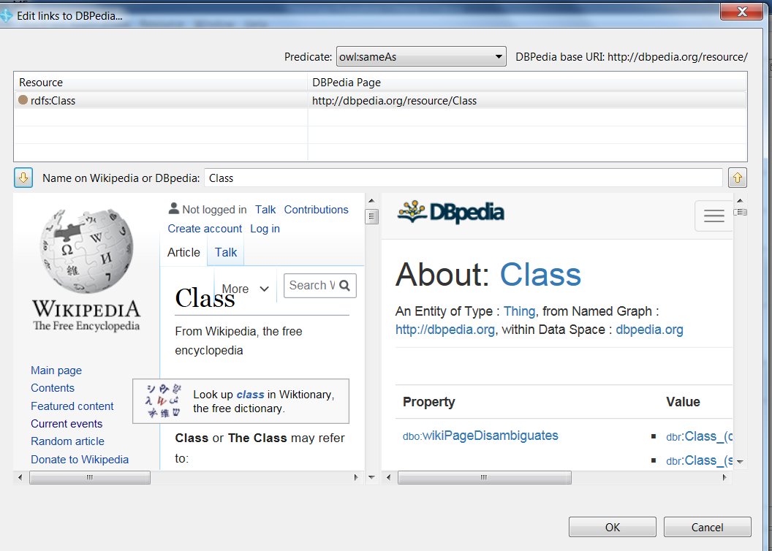

1. Select all instances and put them in a basket

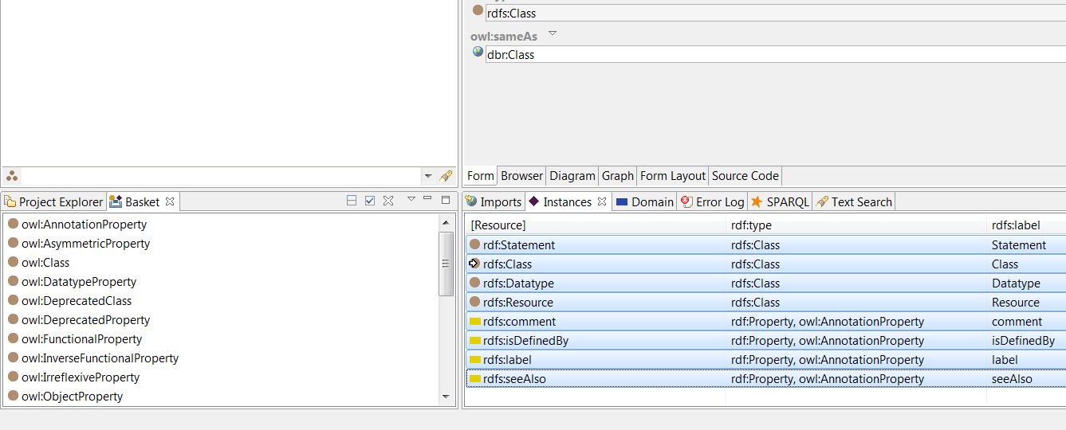

1. Then perform a batch on all instances and get links for all instances

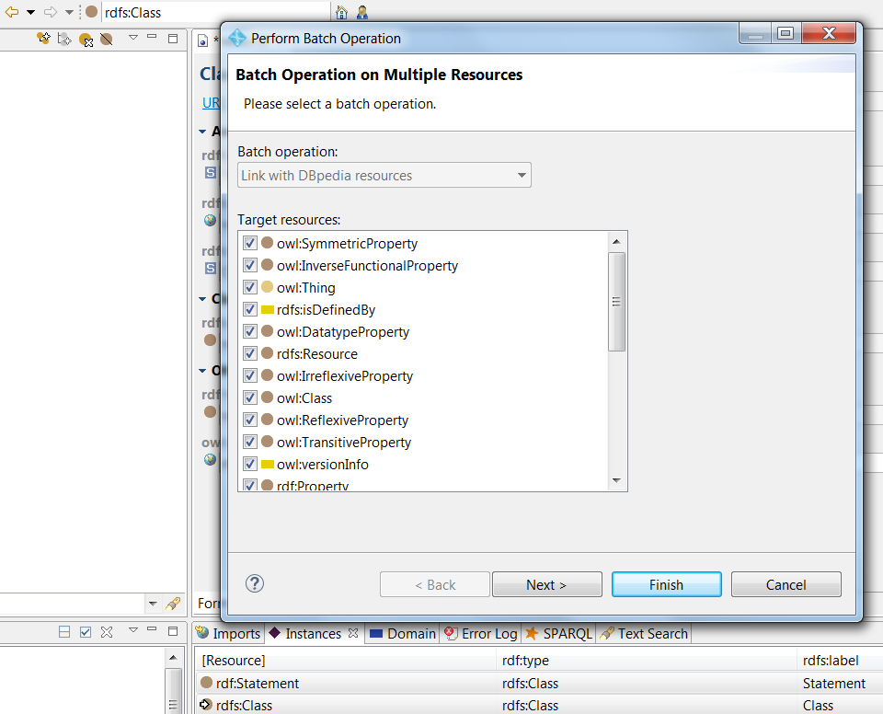

1. Results

